Project Design Phase
Solution Architecture

Date | 2 October 2026
Team ID | Team 7  Team Members: Haresh S (Team Leader), Gobika M, Hariharan M, Harini G
Project Name | Streamlining IT Procurement: Automating Standard Laptop Orders with Flow Designer
Maximum Marks | 4 Marks

Solution Architecture:
Solution architecture is a complex process – with many sub-processes – that bridges the gap between business problems and technology solutions. Its goals are to:
- Find the best tech solution to solve existing business problems.
- Describe the structure, characteristics, behavior, and other aspects of the software to project stakeholders.
- Define features, development phases, and solution requirements.
- Provide specifications according to which the solution is defined, managed, and delivered.

Solution Architecture Diagram:

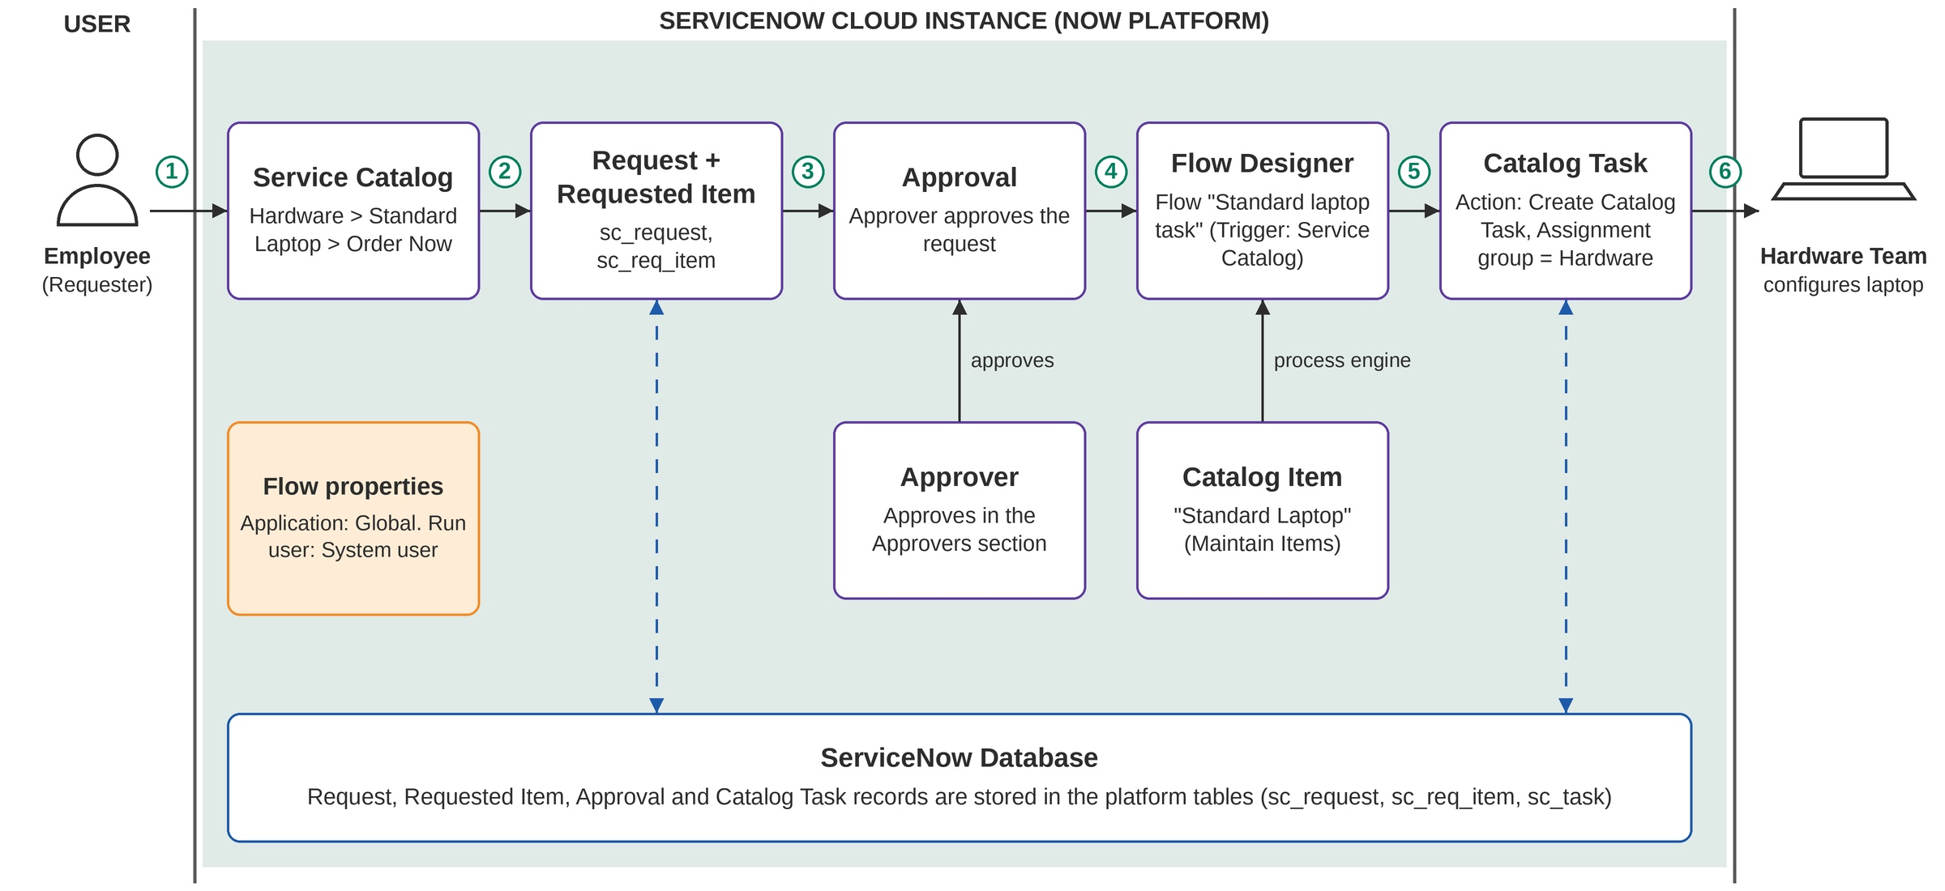
Figure 1: Architecture and data flow of the automated standard laptop order process
Reference: https://www.servicenow.com/in/products/platform-flow-designer.html

